- Purpose
  - The purpose of this document is to describe the procedure for assembling an Optima Propane Burnisher front pulley.
- Scope
  - This SOP applies to all equipment assembly team members. The process applies to the following machines:
E012800EQM0600BE1200 – 21” Optima XR
E012805EQM0600BE1200 – 21” Optima XR w/ Clutch
E012815EQM0600BE1200 – 21” Optima XR w/ Emissions & Clutch
E012830EQM0600BE1200 – 27” Optima XR
E012835EQM0600BE1200 – 27” Optima XR w/ Clutch
E012840EQM0600BE1200 – 27” Optima XR w/ Emissions
E012850EQM0600BE1200 – 27” Optima XR w/ Dust Control
E012860EQM0600BE1200 – 27” Optima XR w/ Clutch & Dust Control
E012865EQM0600BE1200 – 27” Optima XR w/ Emissions & Dust Control
E012875EQM0600BE1200 – 27” Optima XR w/ Emissions, Clutch, & Dust Control
- Responsibilities
  - The operations manager/supervisor is responsible for enforcing this SOP.
- Materials
  - The proper materials needed for this process are listed on the machine work order.
- Definitions

- Procedure
  - The pulley that is used is different depending on what size machine is being assembled. Use 12401 for a 27” machine or 12981 for a 21” machine. Once the correct pulley is selected, hand assemble it and a bushing (12400). The screw and washer needed should be provided with the bushing. Install the screw and washer finger tight at this point.
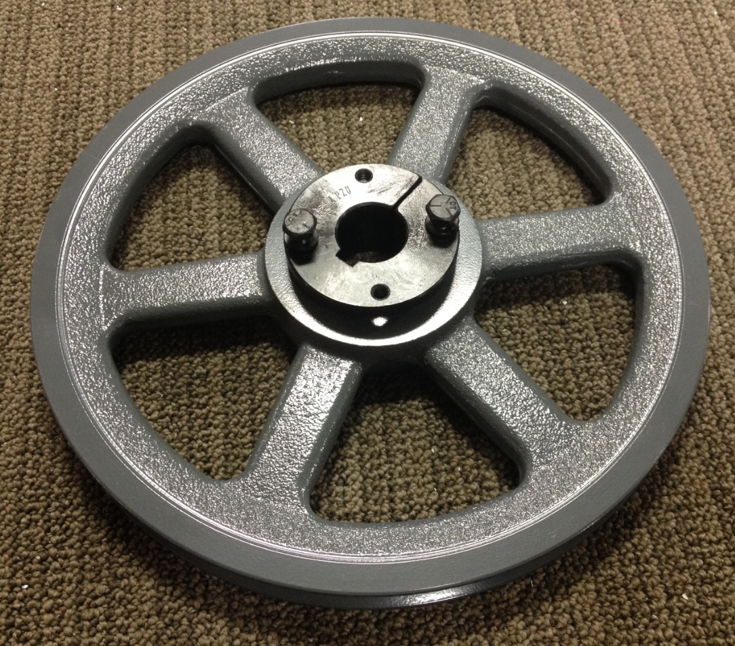
Pulley
Bushing
Screw and washer

- References (optional section as needed)

- Training Guide

Functional Training Groups Requiring Training
Equipment Assembly Group

- SOP Change Control

Date of Change | Reason for Change
Rev 01 - 11/22/2013 | This is the first version of the S.O.P. hence there are no revisions to this document.
Rev 02 - 1/12/2018 | Added Responsibilities Section
Rev 03 - 5/4/2018 | Updated for the Optima XR upgrade
Rev 04 - 3/21/2025 | Removed work center notes

Approvals

Submitter/Author Approval:__________________________________ Date:______________________

Management Approval:______________________________________ Date:______________________

QAU Approval:_____________________________________________ Date:______________________

